**Test The Created Rule**

Step 1 : Check ip address of local machine (**ipconfig**).

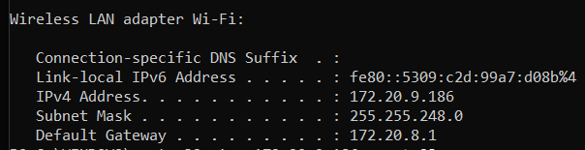

**Step 2** : Using tnc command to check blocked port (Telnet – 23) is open or not.

tnc : It is shortcut of test-NetConnection. Its primary task is to diagnose and troubleshoot network connectivity issues. It is powerful tool make it best alternative of ping tool.

1. Test a specific tcp port.
2. Perform a traceroute.
3. Give detailed results.

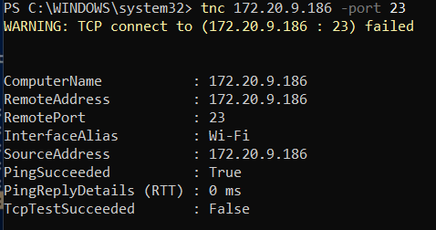

TcpTestSucceeded : false means tcp port blocked . true means port is open.

**Step 3** : After deleting that rule checking telnet port is working or not.